Case 8-A477-Can-Vancouver Is- Kwakwaka'wakw- Dzunuḵ̓wa Mask-1950

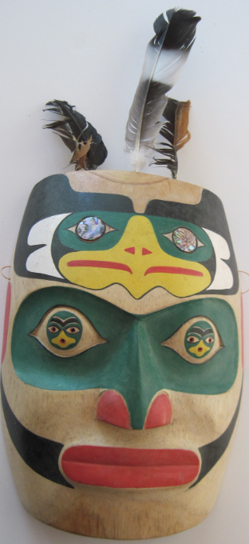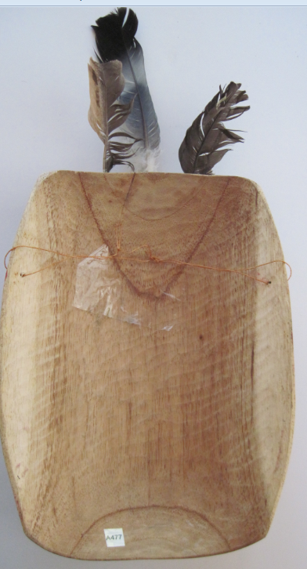

Figs. 1-2. Can-Vancouver Is- Kwakwaka'wakw- Dzunuḵ̓wa Mask-1950

**Case no.: 8**

**Accession Number: A477**

**Formal Label:** Can-Vancouver Is- Kwakwaka'wakw- Dzunuḵ̓wa Mask-1950

**Display Description:**

Dzunuḵ̓wa “is the progenitor of the Namgis clan through her son, Tsilwalagame., but is also greatly feared by children, because she is also known as an ogress who steals children and carries them home in her basket to eat.

She is a naked, black, old monster with long pendulous breasts U'mista Museum, Dzunukwa Mask, Kwakwakawakw Museum in Alert Bay She is also described as having bedraggled hair (Thom 2009: 36).In masks and totem pole images she is shown with bright red pursed lips as in the mask above because she is said to give off the call "Hu!" It is often told to children that the sound of the wind blowing through the cedar trees is actually the call of Dzunuḵ̓wa. Some myths say that she is able to bring herself back from the dead (an ability which she uses in some myths to revive her children) and regenerate any wound. She has limited eyesight, and can be easily avoided because she can barely see. She is also said to be rather drowsy and dim-witted. She possesses great wealth and will bestow it upon those who are able to get control of her child.

In one myth a tribe tricks her into falling into a pit of fire. The tribe burned her for many days until nothing was left, which prevented her from reviving herself. It is said that the ashes that came off this fire turned into mosquitoes.” (Wikipedia 2017)

At the end of a Kwakwaka'wakw potlatch ceremony, the host chief comes out bearing a mask called the geekumhl of Dzunuḵ̓wa, because she is venerated as a bringer of wealth. This is the sign that the ceremony is over. (Wikipedia 2017)

**LC Classification**: E99.K9

**Date or Time Horizon:** Late 20th century

**Geographical Area:** Fort Rupert, northeastern Vancouver Island.

**Map, GPS coordinates:** 50º41'51.16" N 127º25'32.09" W

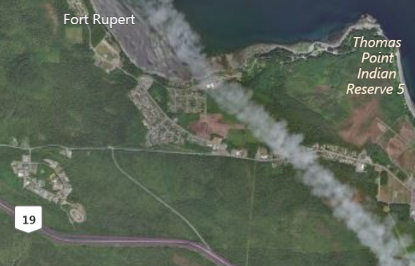

Fig. 3. Map of Fort Rupert and the Kwakwaka'wakw Reserve. After www.bing.com

**Cultural Affiliation:** Kwakwaka'wakw, Kwagu’ł band living at Fort Rupert

**Media:** Wood, red and black paint.

**Dimensions:** **Weight:**

**Condition: original**

**Provenance:** artist

**Description:**

“Dzunuk̕wa appears in both the T̕seka ‘Red Cedar Bark Ceremonies’ and the Tła’sala ‘Peace Dances’. In both ceremonies the dancers will appear with a Dzunuk̕wa mask and a longhaired full-bodied costume, sometimes carrying a large basket strapped to their back. Sometimes extended large hands will be carved to add to the theatrics of the costume. These hands usually have faces painted on the palms to represent sad disobedient children who have been stolen by the Dzunuk̕wa. In most cases, especially in the Tła’sala, the dancer will wear hemlock decorations indicating its connection to the forest. Both dancers will appear from behind the curtain, in the Tła’sala this also signifies coming from the woods. In both ceremonies, the dancer moves about very slowly and rubs their eyes as if very tired and sleepy. They will motion towards the floor as if picking up children and putting them into her basket. In the T̕seka, Dzunuk̕wa is not awake enough to dance the normal four circuits around the fire, but staggers in the wrong direction and when escorted to her seat, she falls asleep; whereas, Dzunuk̕wa in the Tła’sala only dances around the floor once. In another role in both ceremonies, she carries a basket of coppers that she gives to the Chief who is selling or giving them away, or breaking them for a rival Chief” (U'mista Museum. 2009.

Technically, the style and form of masks changed in tandem with access to iron tools and supplies made available after contact with early Russian explorers and European settlers (Holm 1965: 5; Malin 1978: 13; Jonaitis 1991: 39, 54; Masco 1995: 42). Northwest Company and the Hudson Bay Trading Company, which built a trading post near Fort Rupert, in 1849 provided contact with other people. Metal carving tools were sharper and more efficient than their traditional counterparts, and modern synthetic paints allowed for more dramatic and durable coloration than did the plant and mineral based pigments previously used to decorate masks (Jonaitis 1991: 39, 54).

However, the rôle of the past is still evident in the conservatism among some sculptors who refer to the masks of the past in their work. In this respect, masks are highly valued by the Kwakwaka'wakw as manifestations of ancestral spirits and supernatural beings. These supernatural entities are embodied through dance performance (Greenville 1998: 14). However, Northwest Coast tribes vary in their use of different myths, characters, and masks (Malin 1978: 47). Since each mask and accompanying dance programs are “owned” by particular families and passed down by elders and chiefs to their immediate and extended families, they have a certain conservatism in their presentation in the potlatch and seasonal festivals, accruing histories that incrementally transform their meaning (Gosden and Marshall 1999: 172), which is reflected in the way sculptors create new masks based on these transformations (Malin 1978:18-19; Ostrowitz and Jonaitis 1991: 251).

These transformations have been facilitated by Fort Rupert on northeastern Vancouver Island, the traditional homeland of several bands of Kwak’wala speakers. The Kwagu’ł band living at Fort Rupert has been considered one of the highest-ranked bands, with illustrious lineage from myth time to the present and important chiefs. Their home is a site of strong traditional ceremonialism. In 1849, the Hudson's Bay Company established a trading fort there, thus promoting Fort Rupert as a center for commerce and as the most prominent village during the last half of the nineteenth century ideas for transforming masks were freely flowing. George Hunt, of Tlingit and Scottish ancestry (his father was a factor at the fort) but raised in Kwakwaka’wakw traditions, collected valuable information and hundreds of utilitarian and ceremonial objects for museums beginning in the 1890s.

**References:**

Greenville, Bruce. 1998. “Introduction.” In Macnair, et al. 1999, pp. 14-16.

Hawthorn, Audrey. 1979. *Kwakiutl Art*. Seattle: University of Washington Press.

Holm, Bill. 1984. *Form in Northwest Coast Art in Indian Art Traditions of the Northwest Coast*, ed. Roy L. Carlson. Burnaby, B.C.: Archaeology Press & Simon Frasier University.

1972. *Crooked Beak of Heaven*. Seattle: University of Washington Press.

1965. *Northwest Coast Indian Art*. Seattle: University of Washington Press.

Boas, Franz; George Hunt. 1902-1905. *Kwakiutl texts, First and Second Series*. Memoirs of the American Museum of Natural History, v. 14, pt. 1; Publications of the Jessup North Pacific Expedition, v. 10, pt. 1. New York: Knickerbocker Press

Jonaitis, Aldona; Douglas Cole; Stacy Alyn Marcus; Lynton Gardiner. 1991. *Chiefly Feasts: The creation of an exhibition in Chiefly Feasts: The Enduring Kwakiutl Potlatch.* New York and Seattle: American Museum of Natural History and University of Washington Press.

Macnair, Peter. 1998. *Power of the Shining Heavens in Down from the Shimmering Sky: Masks of the Northwest Coast.* Vancouver and Seattle: Douglas & McIntyre and University of Washington Press.

Macnair, Peter; Robert Joseph; Bruce Grenville. 1999. *Down from the Shimmering Sky: Masks of the Northwest Coast.* Vancouver, British Columbia: Dover.

Malin, Edward. 1999. *Northwest Coast Indian Painting: House Fronts and Interior Screens*. Portland, OR: Timber Press.

1978 *A World of Faces: Masks of the Northwest Coast Indians*. Portland, OR: Timber Press.

Masco, Joseph.1995. “‘It is a Strict Law That Bids Us Dance’: Cosmologies, Colonialism, Death, and Ritual Authority in the Kwakwaka'wakw Potlatch, 1849 to 1922,” *Comparative Studies in Society and History* 37 (1): 41-75.

Ostrowitz, Judith, and Jonaitis, Aldona. 1991. “Postscript: The Treasures of Siwidi in Chiefly Feasts: The Enduring Kwakiutl Potlatch” In Aldona Jonaitis, et al., 1991.

Pollock, Donald**.** 1995. “Masks and the Semiotics of Identity,” *The Journal of the Royal Anthropological Institute* 1(3): 581-597.

Thom, Ian M. 2009. McMichael Canadian Art Collection. Douglas & McIntyre.

U'mista Museum. 2009. *Dzunukwa Mask* *of the Kwakwakawakw.* Alert Bay: U'mista Museum.